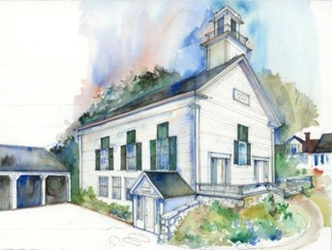

First Congregational Church Wilmot
An Open & Affirming Racial Justice Congregation
Of the United Church of Christ
Gathered in 1829
No matter who you are or where you are on your life’s journey,
you are welcome here!

`
Order of Worship for
August 9, 2026
Rev. Rachelle Eaton, Minister
Elaine Cox, Music Director
MORNING WORSHIP August 9, 2026
A TIME OF GATHERING AND SHARING
Prelude
Words of Welcome and Announcements
Bringing of the Light of Christ
A Time of Silence to Center Ourselves

Our worship service is taking place on N’dakinna, the traditional ancestral homeland of the Abenaki, Penacook and Wabanaki Peoples past and present. We acknowledge and honor with gratitude the land and waterways and the people who have stewarded N’dakinna throughout the generations.
CALL to Worship From Isaiah 55: 1-3
Come to the water, all you who thirst—
come drink deeply from the river of life.

Come to the water, all you who are weary—
come rest in the quiet pools of God’s love.

Come to the water, all you who long for justice—
come be renewed in God’s ever-flowing stream.

For God is here among us,
washing away the dust and grime of our lives,
and pouring out the Spirit on all who thirst.
Let’s worship God together.
INVOCATION
O God, you are our God, the One whom we eagerly seek.
Our souls thirst for you; our bodies long for you
like the parched earth longs for rain when there is drought.
We have met you in this sanctuary and gazed upon your power and glory.
We know that Your unfailing love is better than life itself,
and so we praise you!
We will honor you as long as we live,
lifting up our hands to you in prayer,
calling on your name,
and praising you with songs of joy. Amen

*HYMN “This Is My Father’s World” Chalice # 59

1 This is my Father's world,
And to my listening ears
All nature sings, and round me rings
The music of the spheres.
This is my Father's world:
I rest me in the thought
Of rocks and trees, of skies and seas--
His hand the wonders wrought.

2 This is my Father's world:
The birds their carols raise,
The morning light, the lily white,
Declare their Maker's praise.
This is my Father's world:
He shines in all that's fair;
In the rustling grass I hear Him pass,
He speaks to me everywhere.

3 This is my Father's world:
O let me ne'er forget
That though the wrong seems oft so strong,
God is the Ruler yet.
This is my Father's world:
Why should my heart be sad?
The Lord is King: let the heavens ring!
God reigns; let earth be glad!

HEARING THE WORD OF GOD
Scripture Readings Amos 5:21-24; Jeremiah 2:13
Reflection Rev. Rachelle Eaton
*HYMN “Mountain Brook with Rushing Waters” Chalice #690

1 Mountain brook with rushing waters,
eagle perched in lofty tree,
flowering hillside in the springtime,
white-tailed deer alert and free!
Beauty, beauty all around us!
Jubilate! Sing for joy!
Help us, God, preserve earth’s splendor
for tomorrow’s world to see.

2 Pure the water freshly flowing
toward its ocean destiny,
clean the air of God’s creation,
rich the soil, the mine, the sea.
"Earth is good!" God’s word proclaimed it.
Jubilate! Sing for joy!
Save us, God, from wasteful living,
from pollution’s tragedy.

3 Waving fields of wheat and barley,
giant apples juicy red,
cattle grazing in the pasture;
by God’s bounty we are fed!
Well supplied the world around us!
Jubilate! Sing for joy!
May no greed or warring madness
scorch the earth or rob our bread.

4 Keep us faithful in the struggle
to conserve earth’s threatened store
as we fight to save the forest,
clean the stream, protect the shore.
God and humans work together,
Jubilate! Sing for joy!
Partners working till as stewards
we can say, "Earth’s good!" once more.

MORNING PRAYERS
Sharing of Joys and Concerns
Pastoral Prayer followed by The Lord’s Prayer
Our * … who art in Heaven, hallowed be Thy name. Thy kingdom come, Thy will be done, on earth as it is in Heaven. Give us this day our daily bread, and forgive us our debts as we forgive our debtors. Lead us not into temptation, but deliver us from evil. For Thine is the kingdom, the power, and the glory forever. Amen
*We have come to know God by many different names and images. Please use the one which speaks from your heart today.(e.g. Father, Mother, Creator, God…)
Prayer Response “Restless Weaver” Chalice #658, Verse 2
Where earth's fragile web is raveling help us mend each broken strand.
Bless our urgent, bold endeavors cleansing water, air, and land.
Through the Spirit's inspiration—offering health where once was pain—
Strengthen us to be the stewards of your world knit whole again.
THE GIVING OF OUR GIFTS
OFFERTORY
*Doxology NCH #778
Praise God, from whom all blessing flow;
Praise God, all creatures here below:
Praise God for all that love has done;
Creator, Christ, and Spirit, One.
Prayer of Thanksgiving AND DEDICATION
*HYMN “Let Justice Flow like Streams” NCH #588

1 Let justice flow like streams
of sparkling water, pure,
enabling growth, refreshing life,
abundant, cleansing, sure.

2 Let righteousness roll on
as others' cares we heed,
an ever-flowing stream of faith
translated into deed.
3 So may God's plumb line, straight,
define our measure true,
and justice, right, and peace pervade
this world our whole life through.

*CLOSING CIRCLE AND COMMISSIONING ONE ANOTHER
Go into the world to serve God with gladness; be of good courage; hold fast to that which is good; render to no one evil for evil; strengthen the faint-hearted; support the weak; help the afflicted; honor all people; love and serve God, rejoicing in the power of the Holy Spirit.
*SUNG RESPONSE “Live in Charity” Chalice #523
Live in charity and steadfast love,
Live in charity; God will dwell with you.
(Repeat 3 times)
*BENEDICTION
POSTLUDE
****************
ANNOUNCEMENTS
EVENTS AND MEETINGS THIS WEEK
Thursday, August 13 6:00 pm – AA’s Beginner’s Step Meeting
Sunday, August 16 10:00 am – Worship
11:15 am – Coffee Hour
Saturday, August 22 Bandstand Supper
Sunday, September 13 Rally Day Picnic

First Congregational Church Staff and Officers
Ministers: Members and Friends of the Congregation
Settled Minister: Rev. Rachelle Eaton
Moderator: Bob Evans
Clerk: Open Position
Director of Music: Elaine Cox
Deacon of the Month: Marie MacDonald
Religious Ed Director: Nancy Allenby
Secretary: Mary Heath

Raise the Roof Fundraiseer
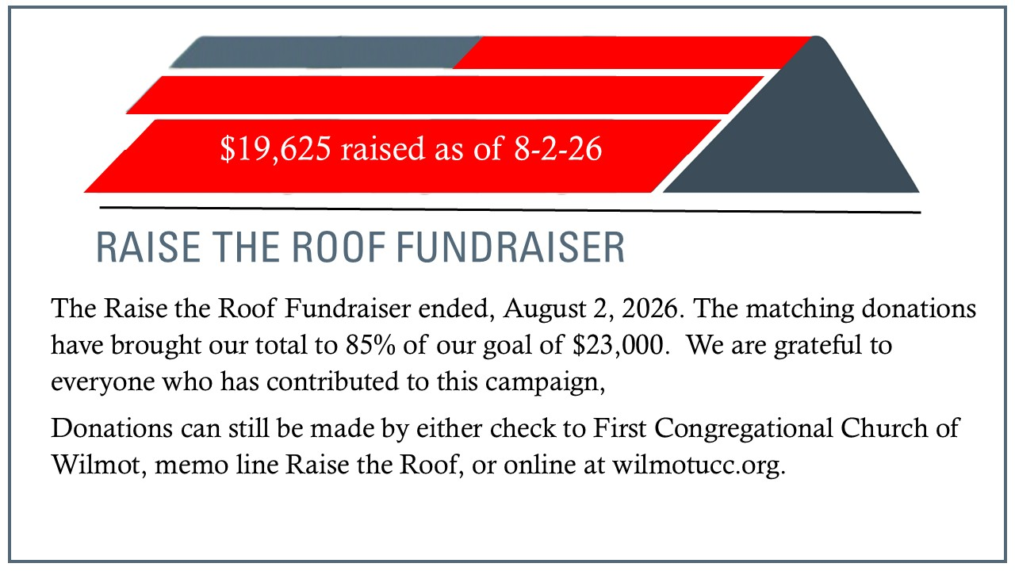

Attributions
Call to Worship by Christine Longhurst.
"Let Justice Flow Like Streams" Text ©1984 Jane Parker Huber, Westminster John Knox Press. All Rights Reserved.
"Mountain Brook With Rushing Waters" Text: William W. Reid, Jr. ©1973 The Hymn Society, used by permission of Hope Publishing Co. All Rights Reserved
Reprinted/Podcast/Streamed/Recorded Audio with Permission under One License #A-742000.
Used with Permission. CCLI Church Copyright License Number: 22643989 and Streaming License Number 22643972.

First Congregational Church Wilmot
Rev. Rachelle Eaton, Settled Pastor
Wilmotucc.org 19 North Wilmot Rd., Wilmot, NH 603-526-7715

