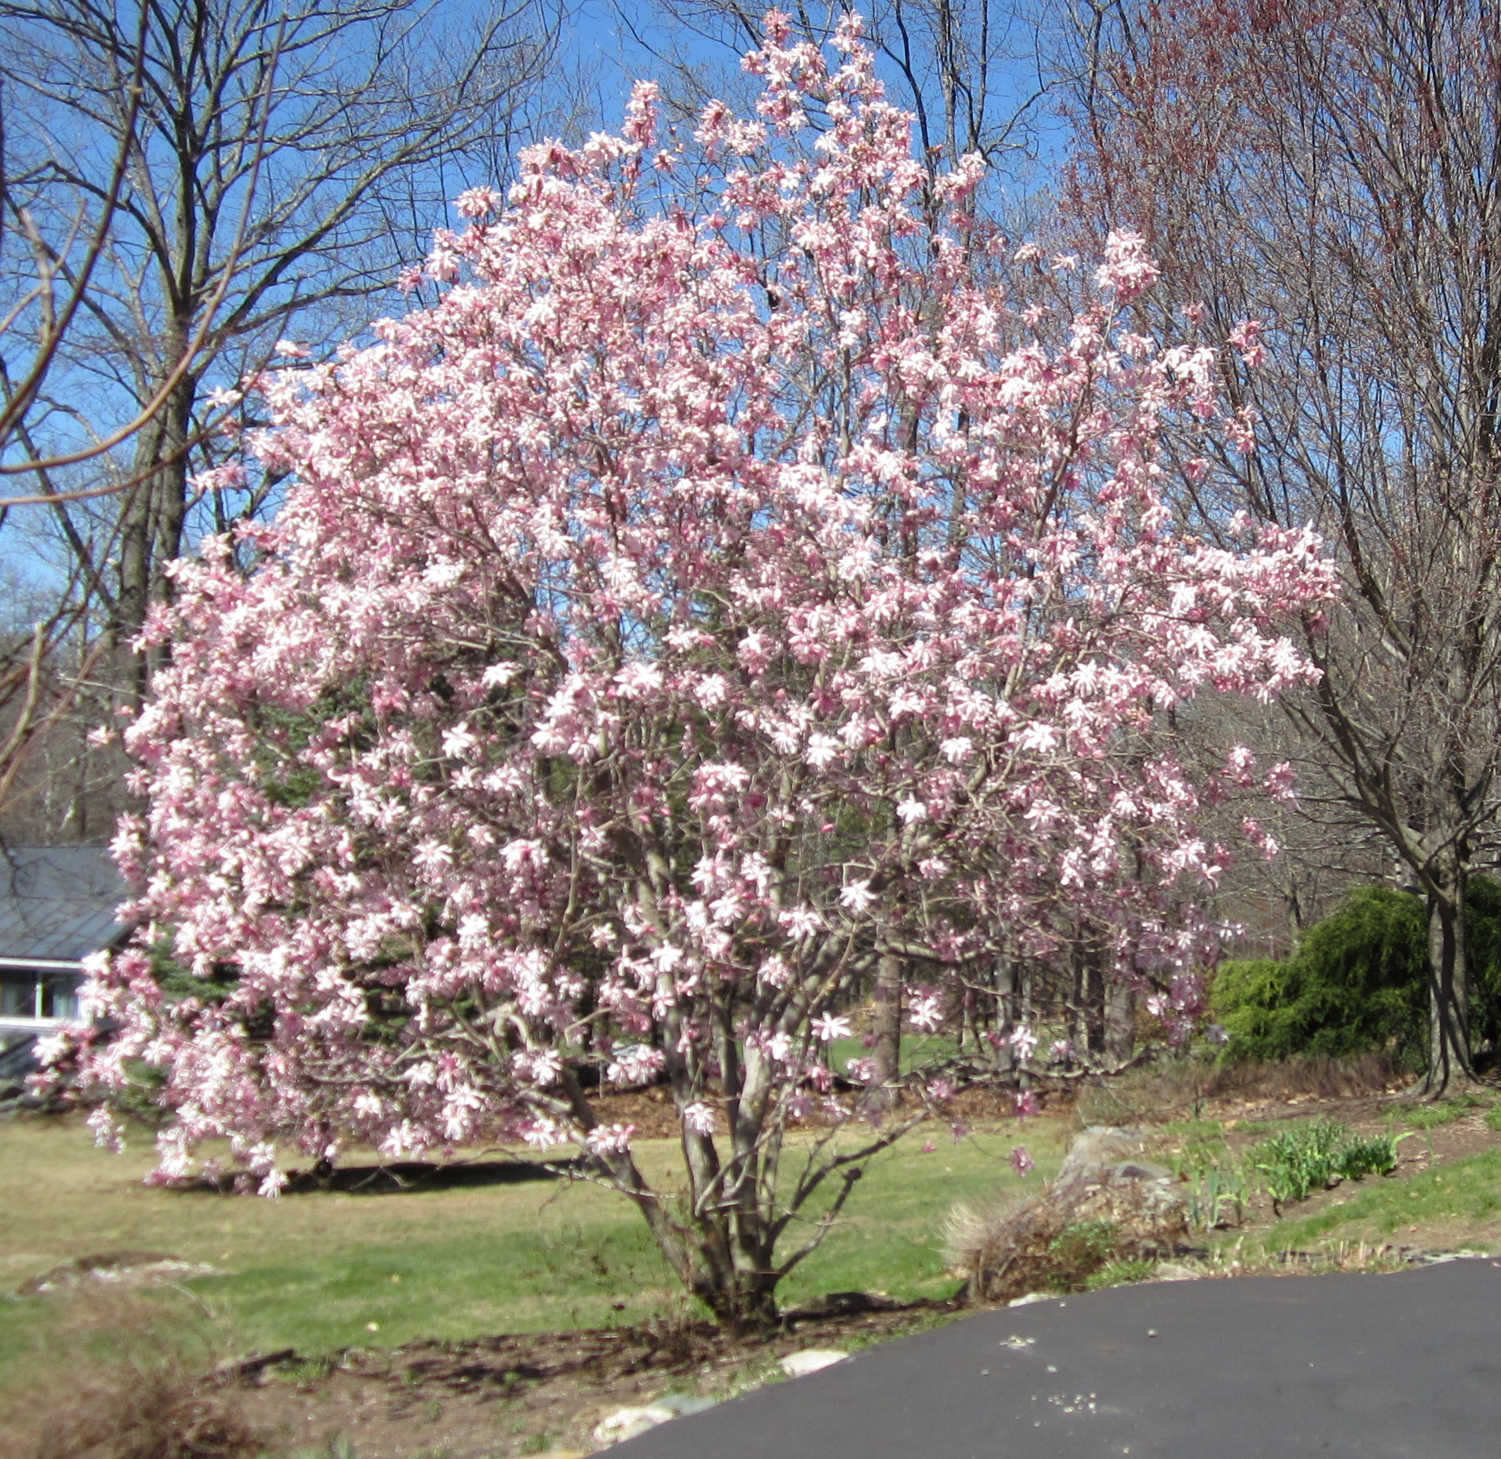

First Congregational Church
Wilmot, New Hampshire
An Open & Affirming Racial Justice Congregation
Of the United Church of Christ
Gathered in 1829
No matter who you are or where you are on your life’s journey,
you are welcome here!
`

Worship Service
May 17, 2026
Rev. Rachelle Eaton, Minister
MORNING WORSHIP May 17, 2026
A TIME OF GATHERING AND SHARING
Prelude
Words of Welcome and Announcements
Bringing of the Light of Christ
A Time of Silence to Center Ourselves

Our worship service is taking place on N’dakinna, the traditional ancestral homeland of the Abenaki, Penacook and Wabanaki Peoples past and present. We acknowledge and honor with gratitude the land and waterways and the people who have stewarded N’dakinna throughout the generations.
CALL to Worship
At the presence of God, we rejoice:
glorifying the One who is Parent of all orphans.
In the presence of Jesus Christ, we listen:
to the Voice who calls us to humbly serve others.
Through the presence of the Holy Spirit, we speak:
making God's love known to the world-forsaken in our midst.
INVOCATION
Giver of power and strength, you take a rag-tag bunch of denying disciples and feckless followers,
creating a new community of servants who seek to do your will.

Keeper of all time, you are enthroned on the rubble of death's shattered power,
calling us to your side and giving us a new vocation,
by which we serve the broken of the communities in which we live.

Constant Presence of hope, you strengthen us so we never give in while confronted by evil; you continually pray for us that we never quit when faith proves to be more of a challenge than we imagined.
God in Community, Holy in One, be among us today.
*HYMN “Womb of Life, and Source of Being” Chalice #14
Womb of life, and source of being, home of ev’ry restless heart,
in your arms the worlds awakened; you have loved us from the start.
We, your children, gather ’round you, at the table you prepare.
Sharing stories tears and laughter, we are nurtured by your care.

Word in flesh, our brother Jesus, born to bring us second birth,
you have come to stand beside us, knowing weakness, knowing earth.
Priest who shares our human struggles, Life of Life, and Death of Death,
risen Christ, come stand among us, send the Spirit by your breath.

Brooding Spirit, move among us; be our partner, be our friend.
When our mem’ry fails, remind us whose we are, what we intend.
Labor with us, aid the birthing of the new world yet to be,
Free the servant lord, and master, free for love and unity.
Mother, brother, Holy partner; Father, Spirit, Only Son
We would praise your name for ever, one in three and three in one
We would share your life, your passion, share your word of world made new,
ever singing, ever praising, one with all, and one with you.
HEARING THE WORD OF GOD
Scripture Readings Philippians 2:1-13
Reflection Rev. Rachelle Eaton
*HYMN “Won’t You Let Me Be Your Servant” NCH #539

Won’t you let me be your servant?
Let me be as Christ to you
Pray that I may have the grace
To let you be my servant too.

We are pilgrims on the journey
We are travellers on the road
We are here to help each other
Go the mile and bear the load.

I will hold the Christ light for you
In the shadow of your fear
I will hold my hand out to you
Speak the peace you long to hear.

I will weep when you are weeping
When you laugh, I'll laugh with you
I will share your joy and sorrow
Till we've seen this journey through.

When we sing to God in heaven
We shall find such harmony,
Born of all we’ve know together
Of Christ’s love and agony.

MORNING PRAYERS
Sharing of Joys and Concerns
Pastoral Prayer followed by The Lord’s Prayer
Our * … who art in Heaven, hallowed be Thy name. Thy kingdom come, Thy will be done, on earth as it is in Heaven. Give us this day our daily bread, and forgive us our debts as we forgive our debtors. Lead us not into temptation, but deliver us from evil. For Thine is the kingdom, the power, and the glory forever. Amen
*We have come to know God by many different names and images. Please use the one which speaks from your heart today.(e.g. Father, Mother, Creator, God…)
Prayer Response “Restless Weaver” Chalice #658, Verse 4
Restless Weaver, still conceiving new life now and yet to be.
Binding all your vast creation in one living tapestry.
You have called us to be weavers. Let your love guide all we do.
With your Reign of Peace our pattern, we will weave your world anew.
THE GIVING OF OUR GIFTS
OFFERTORY
*Doxology “From All That Dwell Below the Skies” Chalice #49
From all that dwell below the skies,
Let the Creator’s praise arise;
Alleluia! Alleluia!
Let the Redeemer’s name be sung,
Through ev’ry land by ev’ry tongue.
Alleluia! Alleluia! Alleluia!
Alleluia! Alleluia!
Prayer of Thanksgiving AND DEDICATION
*HYMN “I Love to Tell the Story” Chalice #480

1 I love to tell the story
of unseen things above,
of Jesus and His glory,
of Jesus and His love.
I love to tell the story
because I know it's true.
it satisfies my longings
as nothing else can do.

Refrain:
I love to tell the story!
'Twill be my theme in glory
to tell the old, old story
of Jesus and His love.

3 I love to tell the story;
'tis pleasant to repeat
what seems, each time I tell it
more wonderfully sweet.
I love to tell the story;
for some have never heard
the message of salvation
from God's own holy Word. [Refrain]

4 I love to tell the story,
for those who know it best
seem hungering and thirsting
to hear it like the rest.
And when in scenes of glory
I sing the new, new song,
'twill be the old, old story
that I have loved so long. [Refrain]

*CLOSING CIRCLE AND COMMISSIONING ONE ANOTHER
Go into the world to serve God with gladness; be of good courage; hold fast to that which is good; render to no one evil for evil; strengthen the faint-hearted; support the weak; help the afflicted; honor all people; love and serve God, rejoicing in the power of the Holy Spirit.
*SUNG RESPONSE “Alleluia” Chalice #106
Alleluia alleluia, alleluia, alleluia,
alleluia alleluia, alleluia, alleluia
*BENEDICTION
POSTLUDE

*******************

Special Notice
Congregational Meeting
Sunday, May 31, 2026
Immediately following the worship service
The Church Council has called a special congregational meeting to approve moving funds from our investment accounts to our cash accounts to cover anticipated expenses.
ANNOUNCEMENT
We are delighted to announce that Elaine Cox will be our new music director. Her first Sunday with us will be on May 31.
EVENTS AND MEETINGS THIS WEEK
Tuesday, May 19 1:00 pm – Justice and Witness
2:00 pm – Growth and Witness
Thursday, May 21 6:00 pm AA's Beginner's Step Meeting
7:00 pm – “Why UCC: A Church of Firsts: A Historic and Ongoing Commitment to Joining Faith and Action”
Sunday, May 24th 10:30 am – Worship and Welcoming New Church Members
Looking Ahead
May 31 at 10:30 am – Special Congregational Meeting
June 7 - Juneteenth Celebration
June 13 – 11 am - Memorial Service for Tom Trent at the church, followed by reception. All are most welcome
June 14 - Children's Sunday
June 21 - Pride Sunday Guest Speaker
First Congregational Church Staff and Officers
Ministers: Members and Friends Clerk: Open Position
of the Congregation Religious Ed Director: Nancy Allenby
Pastor: Rev. Rachelle Eaton Secretary: Mary Heath
Moderator: Bob Evans Deacon of the Month: Bethany Balford
Attributions
Call to Worship and Invocation by Thom Shuman, https://lectionaryliturgies.blogspot.com/
Music; Restless Weaver". Words by O. I. Cricket Harrison, ©1995 Chalice Press. All rights reserved. Harmonization by Ronald A. Nelson, ©1978 Lutheran Book of Worship. Reprinted by permission of Augsburg Fortress. All rights reserved.
"Womb of Life, and Source of Being". Words by Ruth Duck, Music by Ronald Arnatt, © 1992 by GIA Publications, Inc. All rights reserved.
“Won’t You Let Me Be Your Servant?” Words and music by Richard Gillard, ARR. Betty Carr Pulkingham, 1977. All rights reserved.

Reprinted/Podcast/Streamed/Recorded Audio with Permission under One License #A-742000.
Used with Permission. CCLI Church Copyright License Number: 22643989 and Streaming License Number 22643972.

